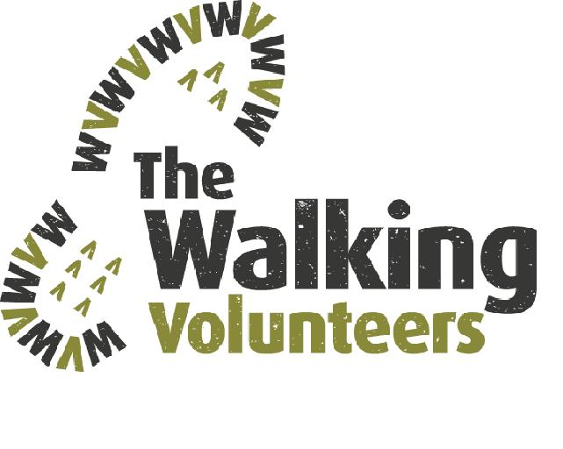

WALKING COASTAL SYDNEY (LINK)

<https://drive.google.com/open?id=1v1OYoO0ujOiL28m9srfApqKCHMB6nk3s&usp=sharing>

DOWNLOAD TO PC

On your PC just click on this link and it will open. Use the +/- button in the bottom LH corner of the map to zoom into any scale that suits you. If you want to view the map in Satellite mode, use the slide on the LH panel and slide down to the satellite button in the LH corner of this panel.

The red lines on the map are the main walking routes - Sydney Harbour & Coast Walk, Great North Walk (to Thornleigh) and Federation Track (to Cronulla). The green lines are the local links and loops that are so important to local walkers. The blue lines are future walking routes. There are also layers for toilets, water fountains, T-way stations and B-line stations and the boxes for those layers may be clicked when needed.

PRINT

Use the snipping tool to select the area you want to print (NEW) and then click on FILE, PRINT to print off your map. Note that you must select a rectangular area if you want to print on one A4 page. If you want to ensure that your map only prints on one page click on SAVE AS rather than print and save the selected area as a .jpg file on your PC and then insert the .jpg file into an MS Word page.

DOWNLOAD TO SMARTPHONE OR TABLET

You can also download the link onto a smartphone or tablet:-

* On an Android phone (Google, Samsung, LG, Sony, HPC, Huawei, Xiaomi, Acer and Motorola) click on this link. You may be asked if you want to open the map in Google Maps. If so, enter ”Y”. If it doesn’t ask you, close the direct link and:-.
  1. Click on the Google Maps app cid:image002.png@01D4F228.B3B7FC60.
  2. Tap Menu cid:image003.png@01D4F228.A4F6FA50 cid:image004.png@01D4F228.A4F6FA50 Your Places cid:image004.png@01D4F228.A4F6FA50 Maps.
  3. Tap the map “Walking Coastal Sydney” which should now be on the Maps menu
  4. You will now be able to follow any walking route as it will show your location on the map,
* On an IPhone or IPad just click on this link and it will open but it will not show your location on the map.
* If you want to show your location on the map on an IPhone:

1. If you have a Google account e.g. you use Gmail just log-in, If you don’t, create a Google account:
   1. Go to [www.google.com](http://www.google.com)
   2. Locate and select the **Sign in** button in the top-right corner. 
   3. Click **Create an account** and enter your details and a password
2. Download the Google Maps app onto your IPhone <https://apps.apple.com/au/app/google-maps-transit-food/id585027354>
3. Then download the map by clicking on the link <https://drive.google.com/open?id=1WPb6QnNn9Wfgr61qiv6dPVKW2SI&usp=sharing>
4. Click on the three dots on the right-hand side of the map legend



1. Click on “Embed map”
2. Click the Google Maps app  cid:image002.png@01D4F228.B3B7FC60.
3. Tap Menu cid:image003.png@01D4F228.A4F6FA50 cid:image004.png@01D4F228.A4F6FA50 Your Places cid:image004.png@01D4F228.A4F6FA50 Maps.
4. Tap the map “Walking Coastal Sydney” which should now be on the Maps menu
5. You will now be able to follow any walking route as it will show your location on the map.

We would appreciate any feedback on the app or the walking routes. Also, please feel free to pass on the link to anyone who might use it.

Walking Volunteers Inc.

02 4784 2002